FAQ for Participants

  - Disclaimer: The information in the pamphlets is made available for the convenient use of the UNJSPF’s participants and former participants. If there is an ambiguity, inconsistency or conflict between the information provided in the pamphlets and the UNJSPF Regulations and Rules, decisions will be based on the Regulations and Rules, and not on the information contained in the pamphlets.

I am a participant and I AM…

Joining

How do I Join the Fund?
You start participating in the Fund when you become a staff member of a UNJSPF member organization and upon being granted an appointment for 6 months or more OR upon completing six months of continuous service without an interruption of more than 30 days, whichever occurs first, provided that participation in the Fund is not expressly (exceptionally) excluded by the terms of your appointment. Your participation in the Fund will commence automatically via a personnel action form (PA) submitted by your employer. Participation in the Fund is mandatory if your contract meets these requirements. You should receive your assigned unique identification number (UID) through your Administrative/Executive Office once you have been enrolled as a participant in the Fund. For more information, check out our Participation page.
Please note that once you qualify for Pension Fund participation, the following options of Validation, Restoration or Transfer of Pension Rights may apply to you; we strongly suggest you read through these options and familiarize yourself with the applicable Regulations and Rules, as well as the information provided on this website, as strict application deadlines apply.

What is my UNJSPF Unique Identification Number (UID)?
Your Unique Identification Number (UID) is a nine-digit number given to all Fund members as a personal pension number forever. Always reference your UID in communication with the Fund. You must always include all nine digits and use the UID number in its entirety on the IPAS system, even if your Unique Identification Number starts with zeroes (for example, 001234567). If you are unsure what your UID is in the new system, you can request your UID from the Fund by emailing RequestUIDonly@unjspf.org.
If you already registered on the UNJSPF website you can retrieve your UID with the information from your former pension number and pin; beneficiaries can click here and participants can click here. For more information and step-by-step instructions, check out our video “How to retrieve your Unique Identification Number (UID)”.

What is the UNJSPF Member Self-Service site and how do I register?
Member self-service provides annually up-to-date information about members’ accounts with access to Annual Pension Statements, estimation tools, and Certificate of Entitlements (CE), and much more. To create a Member Self-Service account you need to have your UID, your last name as it is written in official documents and is registered at the UNJSPF, your date of birth, and an e-mail account. You can access the set-up process at this link or get more information at our Member Self Service Site. For step by step instructions, check out our video…

How do I document prospective survivors to make sure my spouse and child will receive a benefit?
First, ensure you correctly reported your date of birth, personal marital status, and number of children to your employing organization. Second, verify that your pension annual statement accurately reflects this information when it becomes available on MSS by the end of May. If not, you should provide the correct information to your employing organization, which will report that information to the Fund.
Remember, after the date of your separation from service you will not be allowed to request changes to your prospective beneficiaries, your date of birth, or the date(s) of birth of your prospective beneficiaries.
For more information…
Survivor’s Benefit
Child’s Benefit

How do I designate prospective beneficiaries of a residual settlement and what is the A2 form?
Everyone should complete the Designation of Recipient for a Residual Settlement A2 form to assure a Residual Settlement is paid as a one-time lump-sum to the person or institution you chose if you should die in service or after service. The Fund will make such a payment if
- You have no prospective survivors (meaning a spouse, ex-spouse, a child under the age of 21, a disabled child, or a secondary dependant) at the time of your death in service or after service; and
- In the case of death after service, you did not elect to be paid the maximum lump-sum commutation of the benefit allowed, and the total amount of the benefit paid to you or to your survivors is less than your own contributions to the Fund.
In these cases, the Fund pays a residual settlement to your designated beneficiary at the time of your death. The benefit is equivalent to your own contributions to the Fund with compound interest, minus any payments already made to you or your respective survivor(s). The residual settlement is payable to the person or institution designated on your A2 form.
Download the A/2 Form
If there is no duly filled out, dated and signed A2 Form in the Fund’s records, an amount will be paid to the late participant’s/retiree’s estate as a residual settlement. For more information, check out our comprehensive Legal guardianship and estate page.

How do I find my Annual Pension Statements?
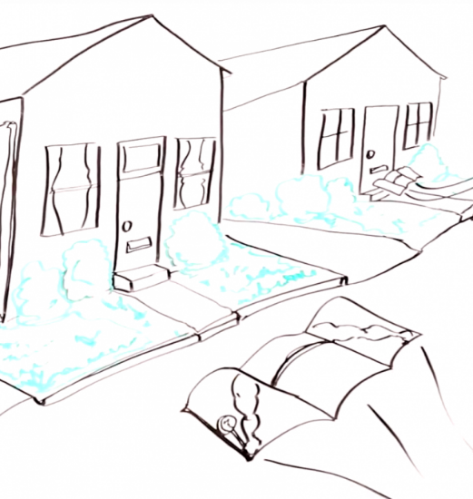
Each year the Fund issues Annual Pension Statements which provide each active participant with information regarding his/her personal marital status and date of birth in the Fund’s records, length of contributory service, total contributions to the Fund and pensionable remuneration (PR). Participants can access their statements at the Member Self Service (MSS) feature on the Fund’s website.
The Pension Statement, previously referred to as the Annual Statement, provides participants of the UNJSPF with details on their contributory service, their accumulated contributions and interest, and the Pensionable Remunerations used to determine their contributions. Additional details are provided for those participants who opted to validate a non-contributory service period or restore a prior contributory service period. The Pension Statement is normally published early May containing details for the previous calendar year.

I have participated in the Fund in the past, and now re-entered the Fund again. What are my options?
If you re-enter the Fund within 36 months from your date of separation your participation in the Pension Fund is deemed to have been continuous (provided that you were not already paid a withdrawal settlement). Your pension contributions will continue to be made to the same account. The period in between your date of separation and of re-entry into Fund participation will be considered a period of break-in-service, which cannot be made pensionable. You do not need to submit any document to the Fund, as your employing organization will provide the required information to the Fund.
If you participated in the Fund in the past and upon separation were paid a withdrawal settlement from the Fund, and you again become a participant in the Fund, you can restore your most recent prior period of contributory service, and make it contributory. Restoration is also available if prior to 01 April 2007 you elected or deemed to have elected a deferred retirement benefit, which was not yet in payment at the time of your election to restore. You must apply for restoration within 12 months from your date of re-entry into Fund participation.
If neither of the above are applicable in your case, upon re-entering the Fund a new pension account will be opened to you, and your contributions for the new period of participation in the Fund will be paid to that account. Your contributions for your new period of participation in the Fund cannot be added to your previous pension account, and you will have two separate pension accounts with the Fund. Upon separation you will be paid a benefit from each pension account separately.

What is Restoration and why choose this option?
Restoration is an option for former participants re-entering the Fund, in which they can add their previous contributory service to their current participation benefits. By restoring, you can increase your total number of years and months of contributory service and thus increase your future pension. Restoration is available only if you elected to be paid a withdrawal settlement for your prior period of contributory service (which you wish to restore) or if prior to 01 April 2007 you elected or deemed to have elected a deferred retirement benefit, which was not yet in payment at the time of your election to restore. You must apply for restoration within 12 months from your date of re-entry into Fund participation.

How do I restore a prior contributory period of service?
Restoration is an option available to former participants re-entering the Fund who would like to add current participation to their most recent period of prior contributory service. Restoration is available only if you elected to be paid a withdrawal settlement for your prior period of contributory service (which you wish to restore) or if prior to 01 April 2007 you elected or deemed to have elected a deferred retirement benefit, which was not yet in payment at the time of your election to restore. Please note, restoration is not the same as validation of previous non-contributory service. If you are re-entering the Fund and would like to restore a prior contributory period of service you must elect to do so within 12 months of re-entering the Fund or prior to your separation from service, whichever is earlier.
Apply for restoration by completing the PENS.C/1-Notice of Election to Restore form and submitting it directly to the Pension Fund or to the Secretary of your local Staff Pension Committee within your employing organization. Your application will be reviewed and if you meet the eligibility requirements, the Pension Fund will calculate the amount that you will have to pay back in order to add your prior contributory service to your present participation. You may opt to pay in a lump-sum or via monthly payments. For more information, continue reading our comprehensive Restoration page.

How do I re-join the UNJSPF after a Break in Service (BIS)?
A break in service refers to the period of time in between your date of separation and date of re-entry into the Fund.
If you re-enter the Fund within 36 months from your date of separation your participation in the Fund is deemed to have been continuous (provided that you were not already paid a withdrawal settlement). You do not need to submit any document to the Fund, as your employing organization will provide the required information to the Fund. Remember, a break in service cannot be made pensionable at any time. Please note, this is not the same as validation of previous non-contributory service.
If you re-enter the Fund after 36 months from your date of separation or after being paid a withdrawal settlement, upon re-entering the Fund a new pension account will be opened to you, and your contributions for the new period of participation in the Fund will be paid to that account. Your contributions for your new period of participation in the Fund cannot be added to your previous pension account, and you will have two separate pension accounts with the Fund. Upon separation you will be paid a benefit from each pension account separately.

I’m Making Changes

What is Validation and why choose this option?
If, before joining the Pension Fund, you had a period of service in a UNJSPF member organization, during which you were not a participant in the Pension Fund, under certain circumstances described in Article 23 of the Fund’s Regulations, you can validate this non-contributory service (i.e., make it contributory) in order to increase your total number of years and months of contributory service and thus your future pension entitlement. Please note, if you become a staff member of a member organization of the Fund on an initial appointment of less than 6 months, you do not immediately qualify for participation in the Fund. Once you do qualify for Fund participation you have the option to validate your prior non-contributory period.
You must apply for validation in writing within one year of first becoming a participant in the Fund, or before the date of separation from service, whichever is earlier. For more information on validation, check out our comprehensive Validation page or How To Validate Tutorial.

How do I validate a non-contributory period of service?
If you’d like to validate a period of non-contributory service with a member organization of the Pension Fund prior to your participation in the Fund, you can opt to pay retroactive contributions even though during this prior period of service you were not eligible to participate in the Fund. You must apply for validation in writing within one year from first becoming a participant in the Fund, or before the date of separation from service, whichever is earlier. Apply for validation by completing the Notice of Election to Validate PENS.B/1 form and submitting it directly to the Pension Fund or to the Secretary of your local Staff Pension Committee within your employing organization. Your application will be reviewed and if you meet the eligibility requirements, the Pension Fund will calculate the amount that you will have to pay in order to add your prior non-contributory service to your participation.
Upon your election to validate your employing organization will pay its own share of contributions to the Fund for the period concerned. For more information on validation, check out our comprehensive Validation pamphlet and our interactive tutorial. Please note that if you have participated in contributory service at the Fund previously, you do not have to validate and you should instead refer to information about re-entry into the Fund and restoration.

How do I Transfer Pension Rights from UNJSPF to another organization?
If your service ends in one member organization of the Fund but continues in another or you join another member organization of the Fund with a break of fewer than 30 days without a benefit having been processed or paid to you, no action is necessary. The member organization that employs you will automatically report your participation status to the Fund and your entitlements and obligations as a UNJSPF participant will continue.
For detailed information on the possibility to transfer acquired pension rights from the UNJSPF to an outside (non-member) organization, or from an outside (non-member) organization to the UNJSPF, the applicable Regulations and Rules as well as conditions and requirements, please check out our comprehensive Transfer Agreements page or continue reading. A complete list of organizations with which the UNJSPF has signed Transfer Agreements, as well as the complete text of each agreement can be found here. Please note that application deadlines apply. Also note that inside Member Self-Service, you can submit an initial request to Transfer-In pension rights.
If you would prefer, once your service ends in one member organization you can opt to delay your benefit payment or election for a period of up to 36 months, so that if you re-join the Fund within the 36 month period, your participation in the Fund will be deemed to have been continuous and your contributions will continue to be paid to the same pension account. Click here for more information about deferred retirement benefits.

Can I pay contributions for period(s) during which I was not employed by a member organization of the Pension Fund?
There are no provisions in the Fund’s Regulations and Rules that would allow to make pensionable any period during which you were not a participating staff member of one of the Fund’s member organizations. However, if you were employed or going to be employed by an organization which signed a Transfer Agreement with the Fund, you may be allowed to transfer your pension rights into/from the Fund in accordance with the provisions of the relevant Transfer Agreement. Please note that application deadlines apply.
For further information, please check out our page on Transfer Agreements. A complete list of organizations with which the UNJSPF has signed Transfer Agreements, as well as the complete text of each agreement can be found here.

What do I need to know about my pension during Special Leave without Pay (SLWOP)?
You have two options:
To pay contributions to the Pension Fund during the period of SLWOP.
In this case the period of SLWOP would be considered contributory service. You would have to arrange this with the payroll office of your employing organization (not with the UNJSPF) BEFORE starting the period of SLWOP, and would be required to pay both your own as well as the organizational share of contributions payable to the UNJSPF. The contributions must be paid monthly and concurrently with such leave and arrangements for the remittance of these contributions must be made between you and the employing organization ahead of starting such periods of SWLOP. You cannot elect retroactively to pay contributions to the Fund for a period of SLWOP, and no retroactive arrangements can be made to contribute for a period of SLWOP when such period has already started or been completed. If contributions are indeed paid concurrently with a period of SLWOP, UNJSPF participation simply continues and you continue to accrue future pension rights for such period of contributory service. However, should you then separate from service and the Fund in the future and elect to receive a Withdrawal Settlement you would not recover the monies you paid to the Fund on behalf of the organization.
Not to pay contributions to the Pension Fund during the period of SLWOP.
In this case you would continue to be considered a participant in the Fund (continuous participation), but would NOT accrue pension rights for this period of non-contributory service. You will be deemed to have separated from the UNJSPF after having completed a period of 36 months of SLWOP without concurrent contributions having been paid to the Fund. Furthermore, spouses married and/or children born during such period of SLWOP without concurrent contribution payments to the Fund, would not be covered for potential survivor’s benefits until you again become a contributing member of the UNJSPF.

How do I update my marital status with the fund in the case of Divorce?
Once a divorce is finalized, you should submit the relevant signed court order including the divorce settlement agreement addressing UNJSPF benefits to the Fund as soon as possible. The Fund will then update your records accordingly. You or your legal representative(s) may contact the Fund’s Client Services Section in regard to divorce proceedings or any issues in the disposition of the UNJSPF pension benefits as part of the divorce settlement.
A divorced surviving spouse could be eligible for a divorced surviving spouse’s benefit if he/she fulfills the requirements in Article 35 bis(b). Furthermore, pursuant to Article 45 of the UNJSPF Regulations, the Chief Executive Officer (CEO) of the Pension Fund has the discretion to remit a portion of a periodic pension benefit to a former or estranged spouse in order to fulfill a legal obligation on the part of a former participant or retiree (e.g. alimony or child support payment) arising from a marital or parental relationship and evidenced by an order of a court. For more information on these requirements or other questions about divorce, check out our comprehensive divorce page.

How do I update my marital status in the case of Non-traditional partnerships/unions?
The Fund recognizes unions/partnerships lawfully entered into and legally recognized by the competent authority of the location where the status was established as long as the union confers similar legal effects as marriage, specifically including pension rights.
Marital status is updated the same way, irrespective of the nature of the marriage or relationship. You should report any change in personal status to your employing organization so your employing organization can then report all changes to the Fund. For more information on eligibility for spousal benefits and determining what kinds of unions recognized by the Fund, check out Article 34 and Article 35 of the Fund’s Regulations & Rules and Guidelines to determine eligibility for spousal benefits.
List of Recognized UNIONS

What is the process of consideration for a disability benefit?
Once you are close to exhausting your sick leave entitlements, your HR Office with liaise with the Medical Services or your employing organization to determine if you should be considered for a disability benefit. In order to be considered for the a disability benefit, you will be required to provide your treating physician’s detailed medical report to your employing organization’s Medical Services and they will provide a recommendation to the Staff Pension Committee, which will award the benefit if they are satisfied that there is sufficient medical evidence to establish that your illness or injury qualifies you for the benefit. For more information, check out our comprehensive Disability Benefits page or continue reading.

I need Finance Estimates & Calculations

How do I run a periodic benefit estimate (standard, normal, early, full, and reduced)?
To find out how to run an estimate of your pension benefit in the UNJSPF Member Self-Service, please refer to our step-by-step YouTube video. And access the estimate tool at Member Self-Service.
Read carefully the choices that you have when you are making an estimate. Understand that the system is making a lot of calculations and it will take it a few minutes to generate the estimate that you requested. Once the calculation is complete the estimate will appear in the Documents tab as a PDF and you can go and open it there. Estimates are just that and the ones calculated through Member Self-Service will not be signed or validated by the Fund. For an “official” estimate participants must still write to the fund.

How do I calculate a withdrawal settlement estimate?
Please refer to our interactive tutorial on calculating withdrawal settlement estimates. For more information on your benefit options, check out our benefit comparison chart.

What is the Standard Rate of Accumulation?
The standard rate of accumulation (RoA) is the rate at which you acquire your retirement benefit, which accumulates for each year of contributory service (CS). The standard rate of accumulation is determined by your date of entry into the Fund. The maximum standard rate of accumulation attainable is 70% of your Final Average Remuneration (FAR).

How do I calculate the Standard Rate of Accumulation?
Refer to the table below for specific information about calculating the standard rate of accumulation.
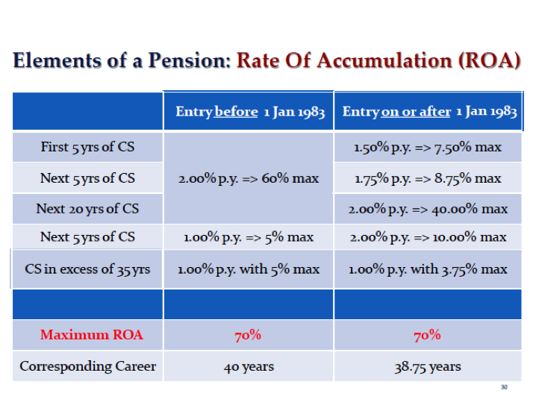

Can I increase or decrease my Pensionable Rate of Remuneration?
Pensionable remuneration is used for determining contributions to the Fund and for calculating pension benefits.
You cannot increase or decrease your pensionable rate of remuneration. For more information or to find out what your pensionable remuneration rate is, refer to our current scale for pensionable remuneration for staff in the professional or higher categories and our current scale for pensionable remuneration for staff in the field service category.

I’m Leaving

What are my benefit options?
The Pension Fund regulates which pension benefit you are entitled to and at what rate at the time of separation from service; your benefit option/s and amount depend on your length of service and age at the time of separation. For more information, check out our Benefit Comparison Page.
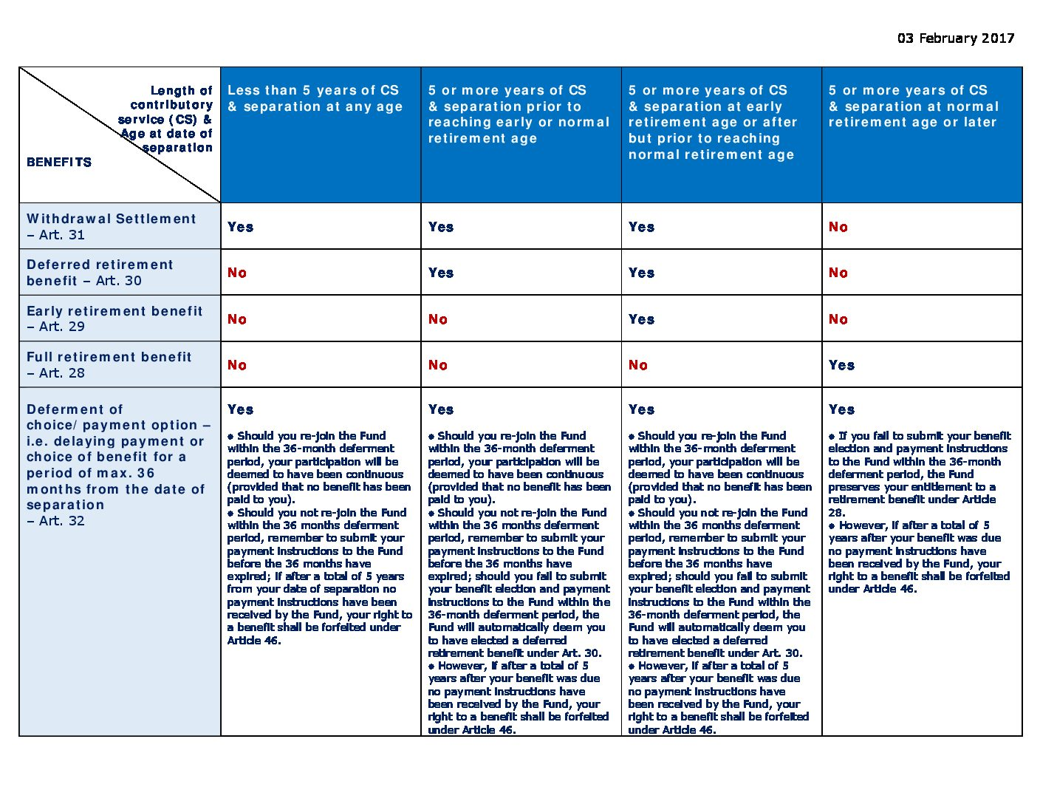

Click here to expand chart.
__________________
Withdrawal Settlement (Article 31)
Opting for a withdrawal statement means your benefit will be received in a one-time payment consisting of the reimbursement of your contributions plus 3.25% interest (increased by 10% for each year after your first five years with the Fund, up to a maximum of 100%). Please note that if you elect a withdrawal statement, no other benefit will be paid to you or your survivors. Should you receive a withdrawal settlement and re-join the Fund in the future you will be entitled to restore the period for which the withdrawal settlement was paid to you.
Deferred Retirement Benefit (Article 30)
Opting for deferred retirement means your benefit will become payable at your normal retirement age or, at your request, anytime between the date at which you become eligible for an early retirement benefit and your normal retirement age. Should you elect to commence your deferred retirement benefit before your normal age of retirement, an according reduction factor will be applied for life to your entitlement. For participants who separated before 31 December 1989 no adjustment shall be applied to their benefit prior to reaching the age of 50. For participants separating from service on or after 31 December 1989 no adjustment shall be applied to their benefit prior to them reaching the age of 55. Such benefit carries potential surviving spouse’s benefit(s) but does not carry eligibility to a child benefit. Furthermore, if you elected a deferred retirement benefit and re-join the Fund in the future you will not be entitled to restore your prior contributory service, and instead you will have a new and separate pension account for the new period of contributory service.
Early Retirement (Article 29)
If you would like to separate before reaching your normal retirement age, opting for early retirement benefits means your benefit will become payable once you have at least reached your early retirement age. If you chose this option, a reduction factor according to your age before NRA will be applied for life to your entitlement. Furthermore, you will be eligible to commute up to one third of the benefit into a lump sum. The benefit carries both potential survivor’s benefits and child benefit. However, payment of child benefit will commence only when you reach your normal retirement age, and only for those children who will be under age 21 at that time. Unless you request payment earlier than your normal retirement age, the Fund will contact you prior to your normal retirement age to request that you submit a payment instructions form (PI) and identification document. For more information on Deferred Retirement Benefit, check out our comprehensive Separation page.
Full Retirement Benefit (Article 28)
You can opt for an un-reduced retirement benefit upon reaching your normal retirement age. You will be eligible to commute up to one third of the benefit into a lump sum. The benefit carries both potential survivor’s benefits and child benefit.
Delaying election of benefit or payout (Article 32)
If you have less than 5 years of contributory service with the Fund you can delay your payout of a withdrawal settlement for a period of up to 36 months. If you have 5 or more years of contributory service with the Fund you can delay your choice of benefit (a withdrawal settlement or a deferred retirement benefit) for a period of up to 36 months. Should you re-join the Fund within the 36-month deferment period from your date of separation from service, your participation will be deemed to have been continuous (provided that no benefit has been paid to you). The period in between your date of separation and of re-entry into Fund participation will be considered a period of break-in-service, which cannot be made pensionable. However, if you do not re-join the Fund, you must submit you benefit election and payment instructions on the according form to the Fund at the latest by the end of the 36 months deferment period. If you have less than 5 years of contributory service and fail to submit your PIs within 36 months your this may lead to eventual forfeiture of your benefit, if after another 24 months no claim has been brought forth. If you have 5 or more years of contributory service with the Fund and fail to submit your benefit election and payment instructions to the Fund within the 36-month deferment period, the Fund will automatically deem you to have elected a deferred retirement benefit.

What is a withdrawal settlement and who is eligible to receive it?
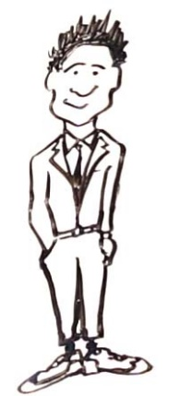
If you have any period of contributory service with the Fund you are eligible to elect a withdrawal settlement. Opting for a withdrawal statement means your benefit will be received in a one-time payment consisting of the reimbursement of your contributions plus 3.25% interest (increased by 10% for each year after your first five years with the Fund, up to a maximum of 100%). Please note that if you elect a withdrawal statement, no other benefit will be paid to you or your survivors. Should you receive a withdrawal settlement and re-join the Fund in the future you will be entitled to restore the period for which the withdrawal settlement was paid to you.
Benefit Comparison Chart

What is a Deferred Retirement Benefit, and who is eligible to receive it?
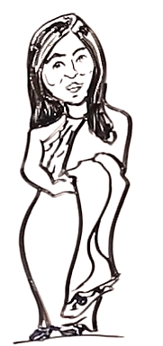
If you have 5 or more years of contributory service with the Fund and you separate from service prior to reaching your normal retirement age you are eligible to elect a deferred retirement benefit. Opting for deferred retirement benefit means your benefit will become payable at your normal retirement age or, at your request, anytime between the date at which you become eligible for an early retirement benefit and your normal retirement age. Should you elect to commence your deferred retirement benefit before your normal age of retirement, an according reduction factor will be applied for life to your entitlement. For participants who separated before 31 December 1989 no adjustment shall be applied to their benefit prior to reaching the age of 50. For participants separating from service on or after 31 December 1989 no adjustment shall be applied to their benefit prior to them reaching the age of 55. Such benefit carries potential surviving spouse’s benefit(s) but does not carry eligibility to a child benefit. Furthermore, if you elected a deferred retirement benefit and re-join the Fund in the future you will not be entitled to restore your prior contributory service, and instead you will have a new and separate pension account for the new period of contributory service. Click here for more information on Deferred Retirement Benefit.

What is an Early Retirement Benefit, and who is eligible to receive it?
If you have at least 5 years of contributory service with the Fund and would like to separate before reaching your normal retirement age, you can opt for an early retirement benefit. If you separate at an age prior to reaching normal retirement age, a reduction factor for life is applied to your benefit. The extent of the reduction depends on your age at the time of separation and the length of your contributory service. It is possible to commute up to one third of the early retirement benefit into a lump sum. The balance would be payable as a reduced monthly pension benefit. The higher the lump sum, the lower your monthly benefit payable for life. The early retirement benefit carries both potential survivor’s benefits and child benefit. However, payment of child benefit will commence only when you reach your Normal Retirement Age, and only for those children who will be under age 21 at that time.
If you entered or re-entered the Fund before 01 January 2014 an early retirement benefit shall be payable to you as of the age of 55.
If you entered or re-entered the Fund on or after 01 January 2014 an early retirement benefit shall be payable to you as of the age of 58.
For more information check out our Benefits Comparison Page.

What is a Full Retirement Benefit, and who is eligible to receive it?
You can opt for an un-reduced retirement benefit upon reaching your normal retirement age. You will be eligible to commute up to one third of the benefit into a lump sum. The benefit carries both potential survivor’s benefits and child benefit.

For more information, check out our Benefit Comparison Page.

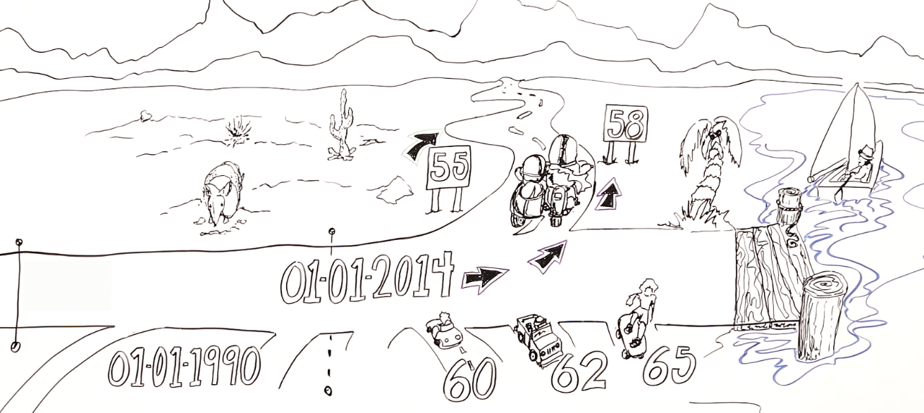
What is the Normal Retirement Age (NRA) for pension purposes?

The Normal Retirement Rate (NRA) determines the age at which a retiring participant would be entitled to a full retirement benefit. This age is determined by the date at which you qualified for UNJSPF entry. If you entered the Fund before January 1, 1990, your NRA is 60. If you entered the Fund between January 1, 1990, and January 1, 2014, your NRA is 62. If you entered the Fund on or after January 1, 2014, your NRA is 65. For more information on NRA and Separation, check out our comprehensive separation pamphlet.

What is the difference between the Normal Retirement Age (NRA) and the Mandatory Age of Separation?
The Mandatory Age of Separation is the age at which you as a staff member must separate from the service of your employing organization. This age is determined by your employing organization. The Normal Retirement Age (NRA) is the age at which you can retire without having your benefit reduced on account of age. The Fund has no say in and no objection to your staying in active service after having reached mandatory age of separation or NRA. You will simply accumulate additional Contributory Service. For more information on NRA, check out our comprehensive separation pamphlet.

What are the Steps and Requirements for Separation from Service?
You should begin the separation process in advance, at least two months before your separation date. It is recommended that you contact the UNJSPF for an estimate of your benefit options within six months of your anticipated separation date or use the interactive Benefit Estimate tool through the Member Self-Service.
To review, calculate and process your benefit, the Fund must receive the following three mandatory separation documents:
1. Payment Instructions Form
Your original Payment Instruction (PI) on the correct form (PENS.E/6 for less than 5 years of contributory service or PENS.E/7 for more than 5 years of service) indicating the benefit option you have selected, the complete bank account information or voided check indicating the account at which you wish to receive payments, the currency of payment, and your email and mailing address with your original ink signature. The Fund must receive the original Payment Instructions form with your original ink signature.
2. Separation Notification form PF4
The original and duly completed, dated and signed Separation Notification form PF4 (financial clearance) issued and submitted to the Fund by the Payroll Office of your employing organization and signed by an authorized payroll or finance officer, detailing your pensionable remuneration and contributions since the end of the previous year; and
3. Separation Personal Action form (SEPPA)
The Separation Personal Action form (SEPPA) issued and submitted to the Fund by your employing organization, and indicating your official date of separation. Discrepancies will delay payments, so if you do not receive your payment promptly, inquire first with your member organization before contacting the Fund. For more information on the process of separation or a detailed guide on how to fill out the Payment Instruction (PI) form, check out our comprehensive separation page. Furthermore, if you elect a periodic benefit, the Fund must receive also the following supporting documents (as applicable in your case) at the latest at the time of separation, in order for the Fund to set up all entitlements correctly:
- a copy of your Birth Certificate or valid passport;
- a copy of your valid photo ID document (e.g. Passport or other valid official, government issued photo ID, carrying your names, date of birth and signature – the “UN Laissez-passer” is NOT a valid ID document);
- a copy of your marriage certificate/s;
- a copy of your divorce decree/s;
- a copy of the birth certificate/s or valid passport of your current and/or former spouse/s (or copy of his/her valid passport or other official, government issued photo ID);
- a copy of the spouse’s official, government issued photo ID;
- a copy of the birth certificate(s) of your dependent child(ren) under 21 years of age;
- a copy of death certificate(s) for spouse(s), ex-spouse(s), child(ren), if applicable; and
- ORIGINAL Designation of Beneficiary form A2

Information on how to Roll-Over Withdrawal Settlement or Lump Sum into an IRA account?
If you would like to request the roll-over of your lump sum or withdrawal settlement from the Fund to an IRA account, please note that the Fund can only remit payments to an account in the name of the participant that is capable of receiving wire transfers. If your account meets these criteria, have your bank provide you with specific instructions as to how they wish to receive payments via wire transfer bearing in mind that the funds will be remitted from JP Morgan Chase Bank in New York City.
Next, fill out the relevant Payment Instructions Form for less than 5 years of contributory service or for more than 5 years of service and, under the Lump Sum banking information box, note to refer to an annex sheet providing the necessary IRA information. Obtain this annex sheet from your financial institution, most will provide you with a form called the Fedwire Instructions Document, detailing what the Fund needs in order to correctly issue the payment. Sign and submit this document to the Fund along with your UNJSPF Payment Instructions. In case you cannot obtain a Fedwire Instructions Document, please detail the following on a blank sheet of paper:
- Line 1: Bank name where financial institution has an account
- Line 2: Address
- Line 3: Address
- Line 4: (United States of America)
- Line 5: Bank identifier (SWIFT, ABA#, CHIPS UID) of Line 1 bank
- Line 6: Name of financial institution
- Line 7: Account number of Line 6 financial institution with Line 1 bank
- Line 8: Beneficiary’s name
- Line 9: (Blank)
- Line 10: Account number of beneficiary with Line 6 financial institution
Note: Print your name, UID, and date on the paper and sign it with your original ink signature

Will the Fund disclose any of my personal or pension information to third parties?
Information you submit exclusively to the Fund for pension benefit purposes (e.g. medical information, designation of beneficiary forms or payment instructions) is confidential and will only be disclosed to third parties if your written consent or authorization has been received, except in response to a court order or a request from a judicial or civil authority in the context of divorce or family maintenance obligations.

How do I obtain information on After Service Health Insurance (ASHI)?
You should always call the Insurance Section of your former employing organization for queries on ASHI. You can opt to have After Service Health Insurance (ASHI) premiums deducted from your monthly pension entitlement. However, the UNJSPF has no authority or insight into ASHI matters. You can contact ASHI with questions at ashi@un.org or through the ‘Contact Us’ portal on their website.

Where do I find information about taxation of UNJSPF benefits?
Information on your own contributions and those of your former employing organization is provided to you in the benefit entitlement letter that is sent to you as soon as your first benefit payment has been processed. If you should misplace the letter, you may request a copy of the letter to be sent to you. Please note that each country determines, based on its own relevant national tax legislation and policies, whether and to what extent UNJSPF pensions are subject to national taxation.
The Fund makes no tax reimbursements to its beneficiaries under any circumstances. Any reimbursement of national income taxes that may be payable on certain UNJSPF benefits is done by the former employing organization. For authoritative advice on tax issues, you should consult your local tax authority or an attorney or accountant who specializes in such matters, or, possibly, consult with the UN Tax Unit where colleagues may be in a position to provide answers. We cannot address tax-related queries because taxation is not within the UNJSPF’s scope or authority. Fiscal periods and national tax laws relating to pensions are exceedingly complex and subject to frequent changes. As a result, the Fund is unable to maintain up-to-date familiarity with this field and unable to give advice to participants regarding taxation. However, the UN Office of Legal Affairs does provide general information about taxation of UNJSPF benefits in our Guide to National Taxation of United Nations and Tax Qualification Letter issued by the US Department of Treasury.

How can I obtain financial advice from the Fund?
The Fund does not provide financial advice. Please seek the assistance of a qualified specialist.

